|  |
| --- |
|  |
| RESEARCH |
| final documentation  BY :  KELANI L.A, Rammutla H.M,  Mokgabudi J.D, Sibanyoni X.J,  Mchunu N.N, Van Wyk J.T,  Choung W.P, Magagula S.F  Mohlabeng M.T, Malinga S.P, |

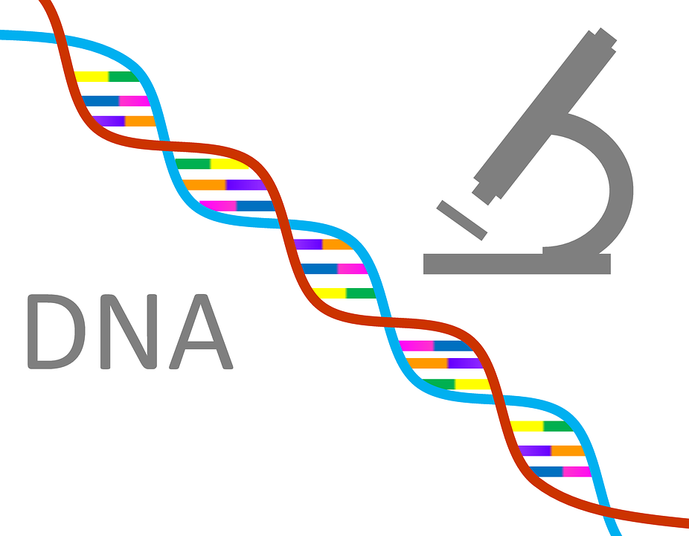

Contents

1. Background 4

2. Problem Statement 4

3. Conceptual solutions 4

4. Proposed Solution 5

5. Introduction 5

6. Objectives 6

7. Methodology 7

8. SWOT Analysis 7

9. Feasibility Study 1

1. Schedule Feasibility 1

2. Operational Feasibility 1

3. Economic Feasibility 1

4. Legal Feasibility 1

10. Stakeholder Management 1

11. Functional and Non Functional Requirements 1

1. Functional Requirements 1

2. Non-Functional Requirements 2

12. User Stories 2

13. Functional Decomposition Diagram 2

14. RACI Matrix 1

15. User Journey Map 3

16. ERD: 4

17. EERD 6

19. Data Dictionary 11

20. Interaction Sequence Diagram 12

21. Dataflow Diagram 13

22. Activity Diagram 17

23. Use Case Diagram: 1

24. State Machine Diagram 1

25. Recommendations 1

26. Conclusion 2

# Background

Postgraduate Students at TUT, are students who are provided opportunities to participate in real-life research issues that affect not only the surrounding communities but the country, continent and the global village. To conduct their researches, they need to submit a topic on which they will be working on in order to be validated. Each Saturday they consult their lecturers/supervisors to present their progress for evaluation and get feed-back from lecturers. At the end of the day, once finish with their projects they need to submit hard copies to be marked and lecturers need to create different folders to keep Student projects. This way of doing overwhelm lecturers, oblige them to be at the Campus every Saturday. Some Students are complaining and asking to remote the process of submission and consultation as many work.

# Problem Statement

TUT does not have any research system that allow Students to conduct or submit their projects/researches to supervisors.

# Conceptual solutions

-Artificial intelligent system: Using artificial intelligent system will help users to do researches without any supervisors. The system should correct mistakes, put everything in order by suggesting the user what, how and where to document.

-Research Template: creating Research Template will help Students/Researchers to create and document their research

# Proposed Solution

Research DNA: A System that will connect both the Student and Supervisor.

# Introduction

TUT is looking for a system that will help students to conduct and submit their researches online. That platform or system should allow supervisors to track and interact with students, Sending feed-back.

It has been discovered that Tshwane University of Technology (tut) staff already have methods, tools and techniques to conduct supervision and for students to carry out their research.

However, these methods and techniques are not efficient enough because the current system uses emails and hardcopies for submitting research projects.

Therefore, we came up with an easier platform Research called Research DNA, to assist and support students in their postgraduate studies and ensure that PG students stays on track.

Research DNA is a workspace or a platform where PG students conduct their research by planning, developing and submitting the project electronically to their supervisor. The system also allows communication between students and their supervisors.​

Is a system that allows Students/Researchers to upload their works and submit them to their supervisors in order to get feed-back?

Is a system or platform that a group of Students/Researchers use to work remotely on a research in order to submit it to a supervisor or department.

# Objectives

This project aims to develop a system that will be fully   
functional within 6-month period of its inception and the purpose of Research DNA system is to assist Postgraduate students and TUT stuff​  
members with more resources related to research and postgraduate​  
supervision.

1. More resources:

Chat Box: allow Students to communicate with other students/researchers and Supervisors

Workspace: allow Students to create a group space to edit new research

Notification Option: allow Student to receive and view new notifications from their Supervisors (Guidance, remarks, feed-back)

Submission: allow Students to submit their progress and final work/research to supervisors

2. Supervision:

Track Student Progress: the system will allow Supervisors to view and track Student progress, how far is the project, what was the last update in order to send remarks and provide guidance.

Submission: the system will allow Supervisor to receive and view Student’s submissions.

The system will be developed in different   
steps by developing components that will be integrated to form a fully functional  
system:

1. The first component that the project aims to achieve is the landing page   
where users will have limited functional experiences but will allow the user to   
create an account profile or login to the system.

2. The second component that is   
required will be the registration which will enable users to create profiles that will  
enable the user to have access to other system components and allow the   
administrator to compile reports based on the account profiles. The   
administrator should be able to produce meaningful reports to stakeholders that   
require them.

3. The third component that this project aims to achieve is the login   
page which will allow the user to access advanced system features.

4. The fourth component that the project aims to achieve is the home page which will be displaying different features to allow the user to choose one.

5. The fifth component that the project aims to achieve is the development of different features:

1. Projects
2. Workspace
3. Research tools
4. Chatbox

# Methodology

The adopted methodology for our project is SCRUM methodology which is a   
project management system that relies on incremental development. Each   
iteration consists of two-to-four-week sprints, where the goal of each sprint is to   
produce the most important features first and come with a potentially   
deliverable product. For this project we will reduce each sprint to one week.

# SWOT Analysis

Before analyzing the Strength, Weakness, Opportunity and Threat of the current process, Let us first mapping or creating the visual presentation of the current process used in TUT for postgraduate students (Steps used by research students)

|  |  |  |
| --- | --- | --- |
| STUDENT | DEPARTMENT | SUPERVISOR/LECTURER |
| Receive Guidance  Propose a Topic  Get Supervisor details  Email Supervisor for Appointment  Start working  Submit Progress using email  Get Feedback  Email Supervisor for Appointment  Restart Working  Submit Final documents | Send Topic Template Proposal/Guidance  Valid Topic?  Send Topic  Ask Student to change Topic  Notify Student  Update Student Marks | Receive Topic  Interested?  No  Yes  Schedule Appointment  Provide guidance  Receive the email Submission  Provide Feedback  Schedule Appointment  Provide more Clarities  Mark final documents  Send Marks to department |

1. After outlining different steps of the current process, we will be analyzing its Strengths, Weaknesses, Opportunities and Threats.

# 9. Feasibility Study

1. Schedule Study

|  |  |  |  |  |  |  |  |  |  |  |  |
| --- | --- | --- | --- | --- | --- | --- | --- | --- | --- | --- | --- |
|  | Priority | Assigned to | Status | Start Date | End Date |  |  |  |  |  |  |
|  | Scrum training |  | Complete | 2022/07/22 | 2022/07/22 |  |  |  |  |  |  |
|  | Sprint 1 |  | Complete | 2022/07/25 | 2022/08/10 |  |  |  |  |  |  |
|  | Business Rules, User Journey, User Stories | Business Analysts |  |  |  |  |  |  |  |  |  |
|  | Prototype for sign up, log in | Business Analysts and Developers |  |  |  |  |  |  |  |  |  |
|  | Landing Page | Developers |  |  |  |  |  |  |  |  |  |
|  | Pilot presentation 1 |  | Presented |  |  |  |  |  |  |  |  |
|  | Sprint 2 |  | Complete | 2022/08/15 | 2022/08/31 |  |  |  |  |  |  |
|  | Functional and Non-Functional Requirements, ERD, Dataflow Diagram, Activity Diagram | Business Analysts |  |  |  |  |  |  |  |  |  |
|  | Mock-up | Business Analysts and Developers |  |  |  |  |  |  |  |  |  |
|  | Implementation of Sign up and log in pages, Database | Developers |  |  |  |  |  |  |  |  |  |
|  | Pilot presentation 2 |  | Presented |  |  |  |  |  |  |  |  |
|  | Sprint 3 |  | Complete | 2022/09/01 | 2022/09/15 |  |  |  |  |  |  |
|  | Minimum Variable Product, Sequence Diagram | Business Analysts |  |  |  |  |  |  |  |  |  |
|  | Mock-up for Student Dashboard | Business Analysts and Developers |  |  |  |  |  |  |  |  |  |
|  | API, Dashboard and Student profile implementation | Developers |  |  |  |  |  |  |  |  |  |
|  | Pilot presentation 3 |  | Presented |  |  |  |  |  |  |  |  |
|  | Sprint 4 |  | Complete | 2022/09/15 | 2022/09/30 |  |  |  |  |  |  |
|  | Class State Machine, Interaction sequence and Decomposition Functional Diagrams, SWOT Analysis, RACI Matrix and EERD | Business Analysts and Developers |  |  |  |  |  |  |  |  |  |
|  | Prototype for Supervisor Dashboard and Research Tools | Business Analysts and Developers |  |  |  |  |  |  |  |  |  |
|  | APIs, Implement Feedback and My project components | Developers |  |  |  |  |  |  |  |  |  |
|  | Pilot presentation 4 |  | Presented |  |  |  |  |  |  |  |  |
|  | Sprint 5 |  | Completed | 2022/10/01 | 2022/10/15 |  |  |  |  |  |  |
|  | Feasibility Study, Final Documentation, EERD | Business Analysts |  |  |  |  |  |  |  |  |  |
|  | Prototype for Admin | Business Analyst |  |  |  |  |  |  |  |  |  |
|  | Research Tools, Project and project status, submission and chat box implementation | Developers |  |  |  |  |  |  |  |  |  |
|  | Pilot presentation 5 |  | Presented |  |  |  |  |  |  |  |  |
|  | Sprint 6 and Sprint 7 |  | Completed | 2022/10/15 | 2022/11/30 |  |  |  |  |  |  |
|  | Updating ERD and EERD, Final Documentation, Attendance register report, Updating User stories, system features report | Business Analysts |  |  |  |  |  |  |  |  |  |
|  | Prototype for announcements | Business Analyst |  |  |  |  |  |  |  |  |  |
|  | Chat box, Admin components, API for project | Developers |  |  |  |  |  |  |  |  |  |

Research DNA System will improve the quality of researches done by Students as the system will be providing Research Tools option where users could check previous researches to be inspired

1. Operational Feasibility

The probability that system works all the time and everywhere is 90%.

The User can use any electronic device to access the system from every place that the internet can be found.

The system will be able to support or manage many users at the same time more than 50000

How to Use Research DNA?

1. The User needs to register to the system by filling the registration form
2. After registering, the User will be allow to log in by filling the Login form
3. Once the access is granted, the User may open a workspace where he could edit its researches and submit to a supervisor and he can also use the system to interact with supervisor and get feedback
4. Economic Feasibility

By selling the system to other institution or by exposing the system to a large number of Students, TUT may earn more than R500000

R80000

R100000

1. Legal Feasibility

# Stakeholder Management

# Functional and Non Functional Requirements

## Functional Requirements

1. For Landing Page

|  |  |  |  |
| --- | --- | --- | --- |
| Functional  Requirement ID: | Functional  Requirement  Description | Mandatory/ Not  Mandatory | Purpose |
| ID No. | The system  must/should |  |  |
| FR01 | Allow users to Register | Mandatory | Open an Account |
| FR02 | Allow users to enter his details: name, student Number, email address | Mandatory | Avoid to have someone to have many account using the same details |
| FR03 | Allow users to create Password and confirm that Password | Mandatory | Authentication to avoid Hackers |
| FR04 | Allow users to submit the Registration Form | Mandatory | Send User details to the Database |
| FR05 | Allow users to login | Mandatory | Grant User Access |
| FR06 | Allow users to enter his details: name, password | Mandatory | Verify if the user is registered |
| FR07 | After login allow users to land on home page | Mandatory | Allow User to do what he wants by displaying different option |

1. For Home Page

|  |  |  |  |
| --- | --- | --- | --- |
| Functional  Requirement ID: | Functional  Requirement  Description | Mandatory/ Not  Mandatory | Purpose |
| ID No. | The system  must/should |  |  |
| FR01 | Display Menu | Mandatory | Allow User to choose an option |
| FR02 | Allow users to Create new Research | Mandatory | Edit a research or project |
| FR03 | Allow users to Create Workspace | Mandatory | Add Students for a group work |
| FR04 | Allow users to view notifications | Mandatory | Receive new updates |
| FR05 | Allow users to send and receive messages | - | Communication |
| FR06 | Allow users to submit researches | Mandatory | Submit Final document |
| FR07 | Allow users to logout | Mandatory | Exit/close the session |

## Non-Functional Requirements

|  |  |  |  |
| --- | --- | --- | --- |
| Non-Functional  Requirement ID: | Non-Functional  Requirement  Description | Mandatory/ Not  Mandatory | User  Expectations |
| NFR001 | •Security •Account  Creation –  The system  must allow  users to  create an  account to  access the  system, store, and display  user profiles.  Allow  administrator  to create  reports based on profile  information  and usage. •Password and username  generation –  the system  may not allow a user access  without a  username and a password.  The password must be  strong and must be a  combination  of characters  that are  composed of  at least two  uppercases  character,  two lowercases character,  two numbers,  and one  special  character.  The password must be at  least 8  characters  long and have a maximum  length of 16  characters.  The password must not  contain the  username  name,  surname, or  ID number. •User  verification –  the system  must allow  the user an  option to  choose a  method of  recovery.  From  answering 3  security  questions and email  verification to retrieve  and/or  change  password. | Mandatory | The system  must be able  to secure  sensitive user data. |
| NFR002 | •Portability –  the system  must be able  to function  across all  web-enabled  Devices and  allow the user to access all  functions if  they have  passed the  security  protocols. |  | The system  must allow  the user to  use devices  interchangeably to allow  The user to  have an  option of  using any  available  device. |
| NFR003 | Compatibility – the  system must be  compatible with all  web-enabled  devices and run  while other  applications are  running on the same device without  disruption. |  | The system  must be  compatible to any device  that a user  has access to. |

# User stories

# 

|  |  |  |
| --- | --- | --- |
| AS A | I WANT TO | SO THAT I CAN |
| Student | Create an account | Have access to the system |
|  | Have access | Conduct my research |
|  | Have access | Attach files for submitting my research |
|  | Have access | I can interact with the supervisor whenever I have queries |
|  | receive notifications | Receive feedback on my research |
|  | Have access | I can keep track my progress |
|  | Access the system | Edit the research |
|  | Have access | Access the information platform |
|  | Access the system | Interact with other students |
|  | Have access | download my research incase it's ready for publishing |
| Supervisor | Access the system | conduct supervision on my students' research |
|  | Access the Chabot | answer any queries students might have |
|  | Be able to send notifications | give students feedback about their research |
|  | Access the system | Can track student progress |
|  | Send Updates to students | Notify students of any new developments |
| Administrator | Have access | Accept and verify users |
|  | Have access | Manage content |

# Functional Decomposition Diagram

## For Student

## For Admin

## For Supervisor

# RACI Matrix

Our RACI chart is defining whether the people involved in a project activity will be Responsible, Accountable, Consulted, or Informed for the corresponding task, milestone, or decision.

Legend:

* Responsible
* Accountable
* Consulted
* Informed

|  |  |  |  |  |  |  |  |  |  |  |  |
| --- | --- | --- | --- | --- | --- | --- | --- | --- | --- | --- | --- |
| Project Deliverables/Activity | Project Leadership | | | | | Project Business Analysts | | | Project Developers | | External Resource |
|  | Project Manager | Business Analyst Leader | Developer Leader | System Analyst/Tester Leader | Project Leader | Jessica | Nokuthola | Arnold | Front End | Back End | Product owner |
| Background | I | C | I | I | A | C | C | R | I | I | I |
| Problem Statements | I | C | I | I | A | C | C | R | I | I | I |
| Solution | I | A | I | I | R/A | C | C | C | I | I | C |
| Requirements | I | C | I | I | A | C | C | R | I | I | C |
| UML Diagrams |  | C | I | I | A | R | R | R | C | C | C |
| Methodology | R/A | C | C | C | C | I | I | I | I | I | I |
| User Journey | I | C | I | I | A | C | R | C | I | I | I |
| Landing Page | I | I | C | I | A | I | I | I | R | C | I |
| ERD and EERD | I | C | C | I | A | R | C | C | I | C | I |
| Database | I | I | C | C | A | I | I | C | C | R | I |
| Home Page | I | I | C | I | A | I | I | I | R | C | I |
| Features Pages | I | C | C | C | A | C | C | C | R | R | I |
| Final Approval | R/A | C | C | C | C | I | I | I | I | I | C |

# User Journey Map

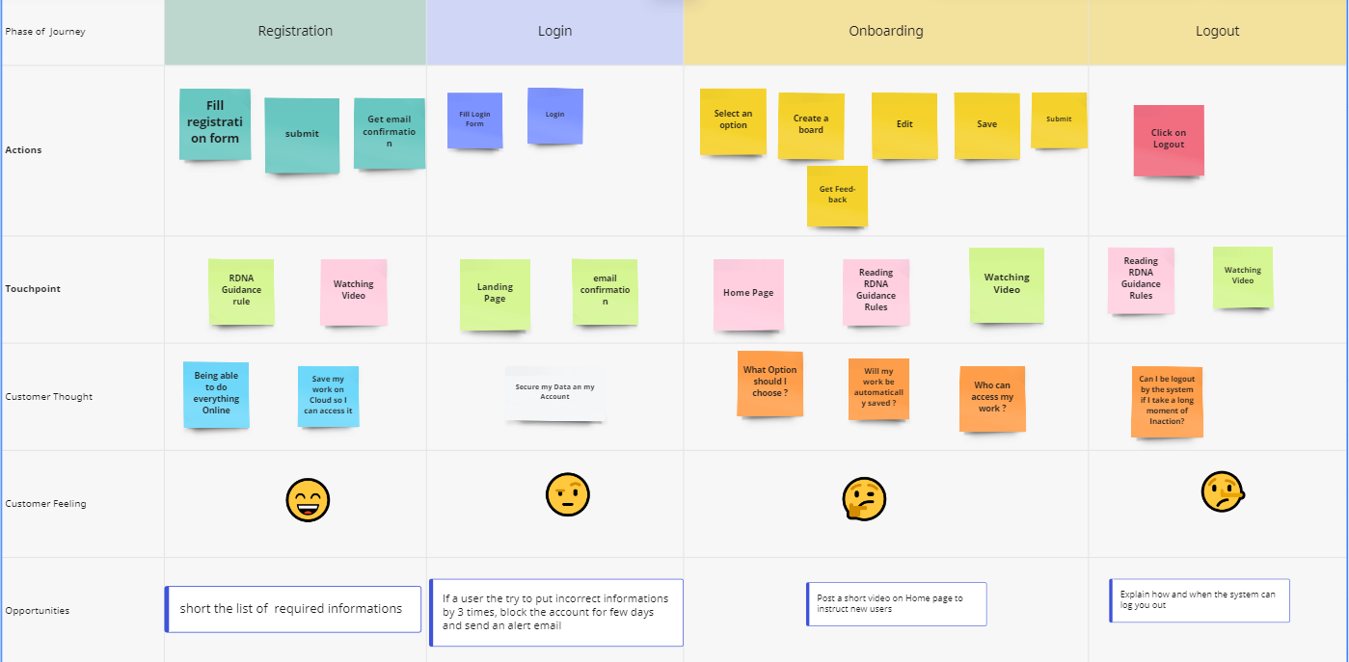

# ERD:

### C:\Users\Student\Pictures\Screenshots\Screenshot (1).png

1. EERD
2. For Student

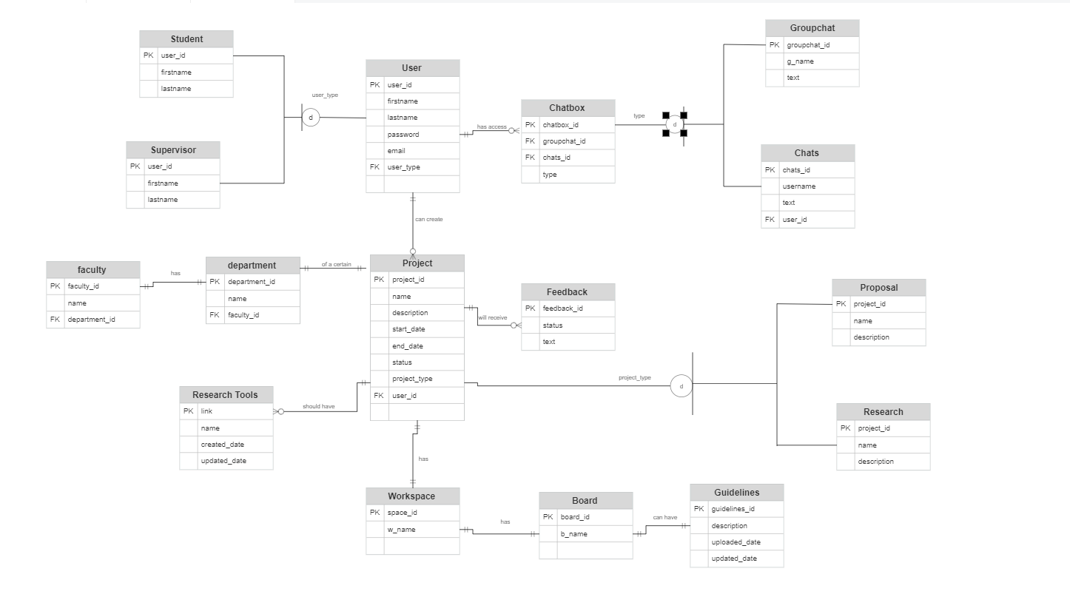

1. For Supervisor

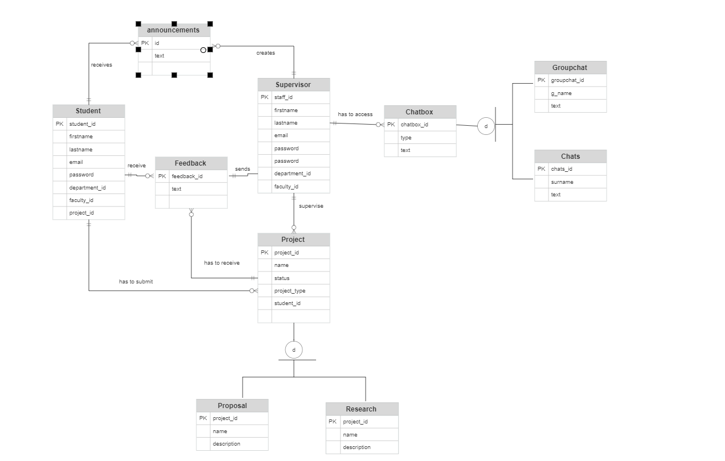

18. Class Diagram

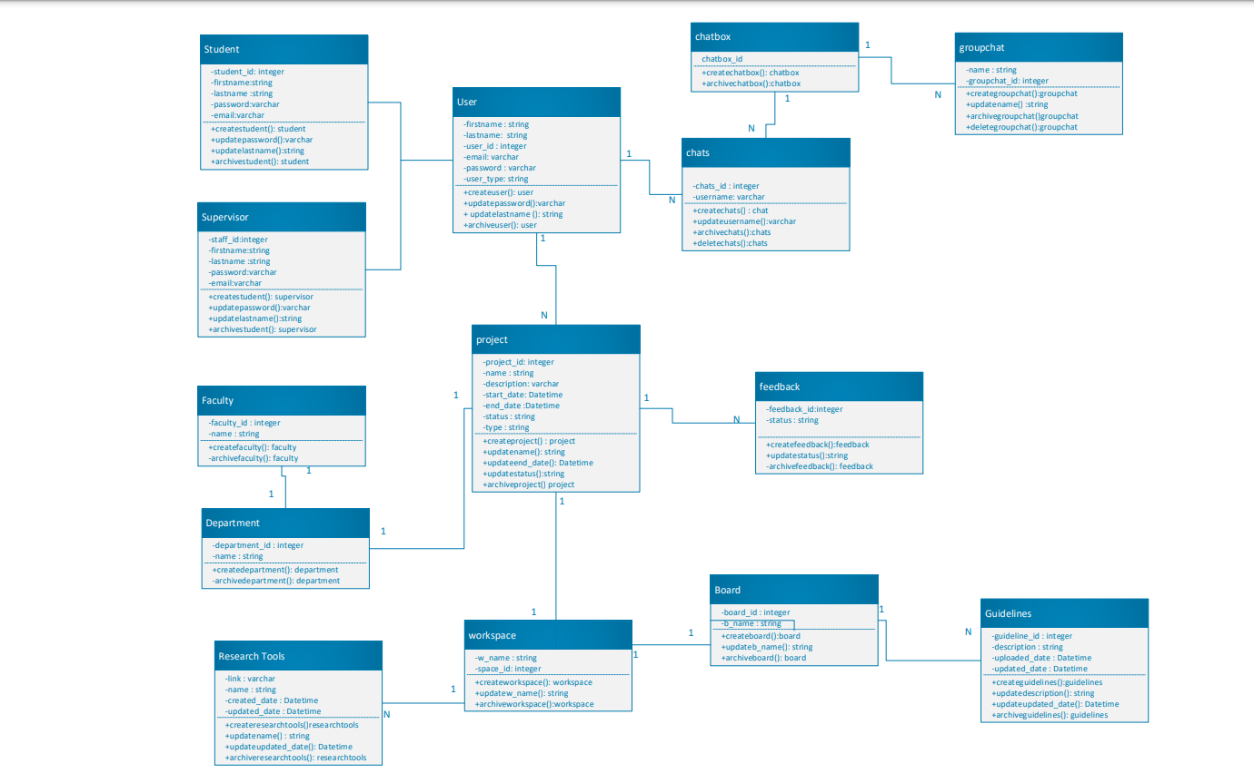

# Data Dictionary

|  |  |  |  |  |  |
| --- | --- | --- | --- | --- | --- |
| Field Name | Data Type | Data format | Field size | Description | Example |
| User_id | Integer | 12345 | 9 | Unique student/ stuff number for each users | 217591260 |
| First name | Varchar | ZZZZ | 20 | First name(s) for all users | Jessica Dimakatso |
| Last-name | Varchar | NNNN | 50 | Last name for each user | Mokgabudi |
| Email | Varchar2 | NNNN | 50 | Work/student email for all users | 217591260@tut4life.ac.za |
| Password | Varchar2 |  | 20 | A password to secure the account of each user | Dima#55 |
| User type | Varchar | NNNN | 15 | Differentiates the users. | Student |

# Interaction Sequence Diagram

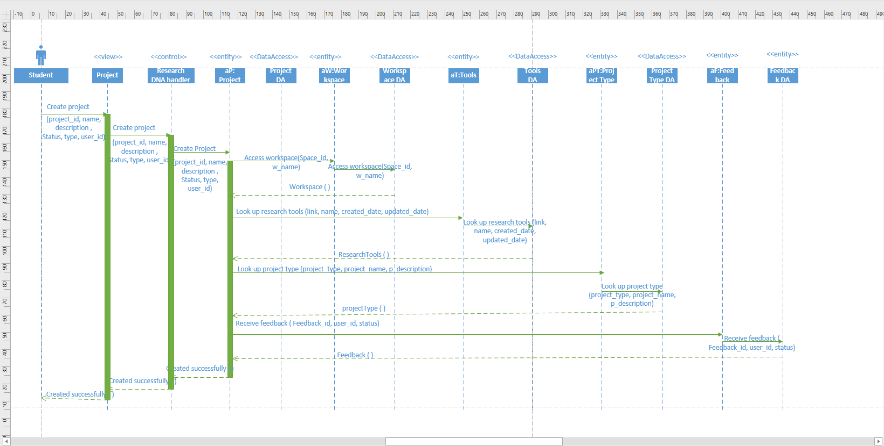

# Dataflow Diagram

1. For Student

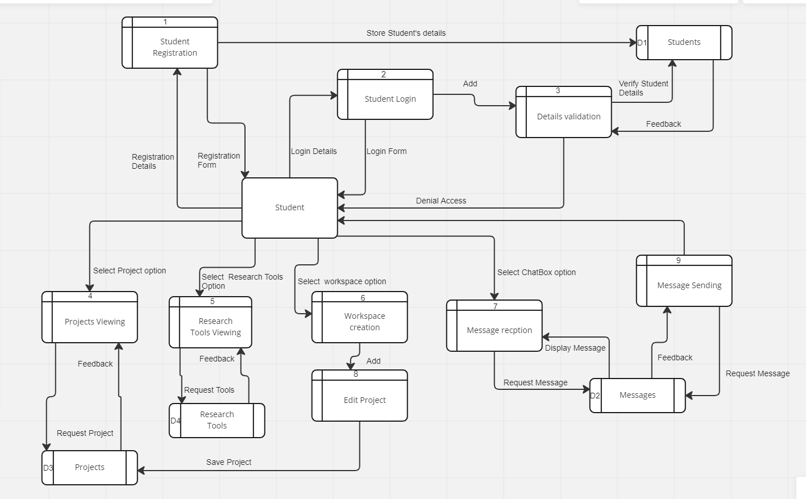

1. For Supervisor

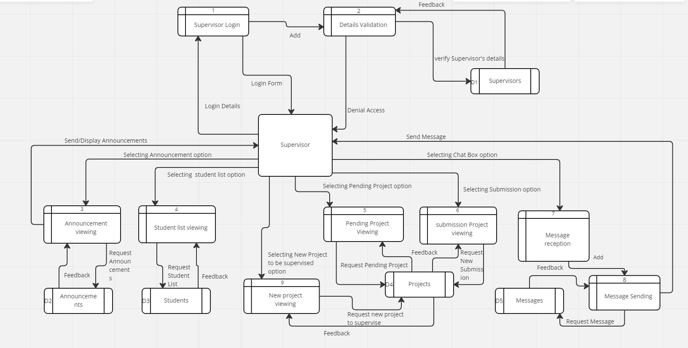

1. For Admin

# C:\Users\Student\Pictures\Screenshots\Screenshot (2).png

# 22. Activity Diagram

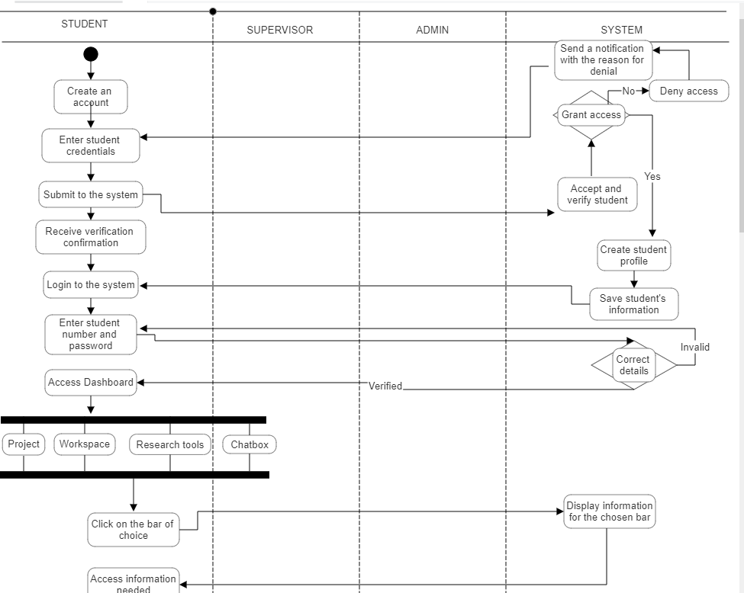

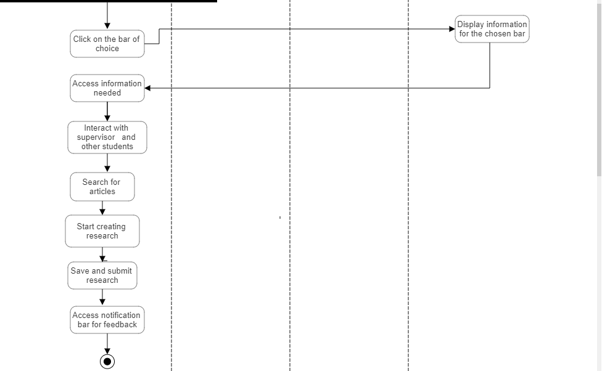

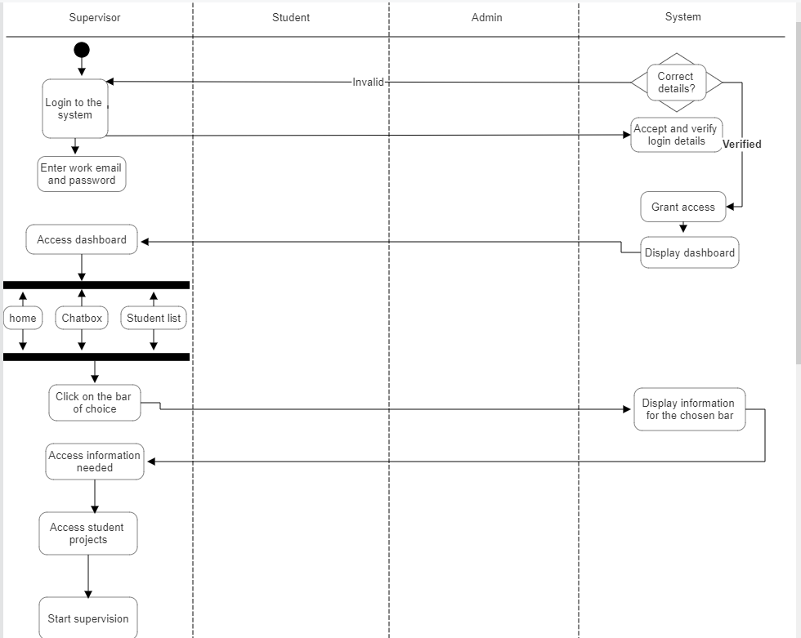

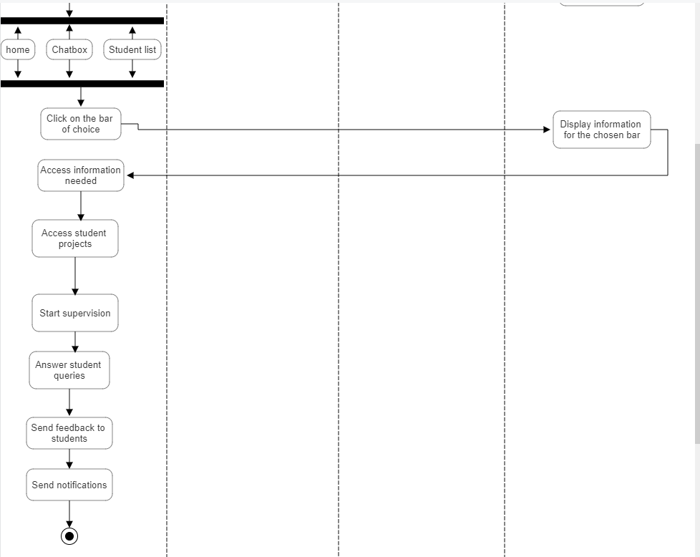

# Use Case Diagram:

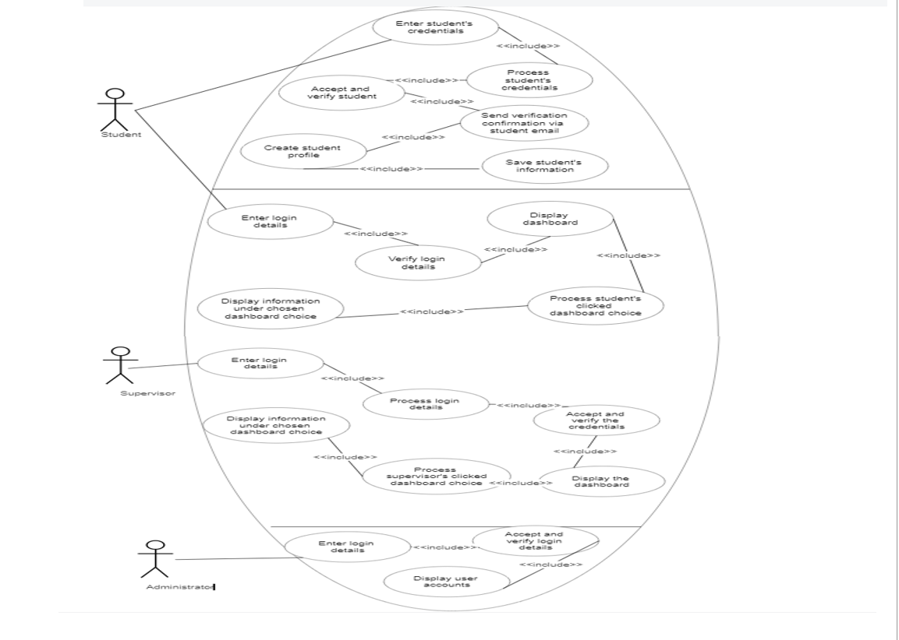

# State Machine Diagram

1. For Student

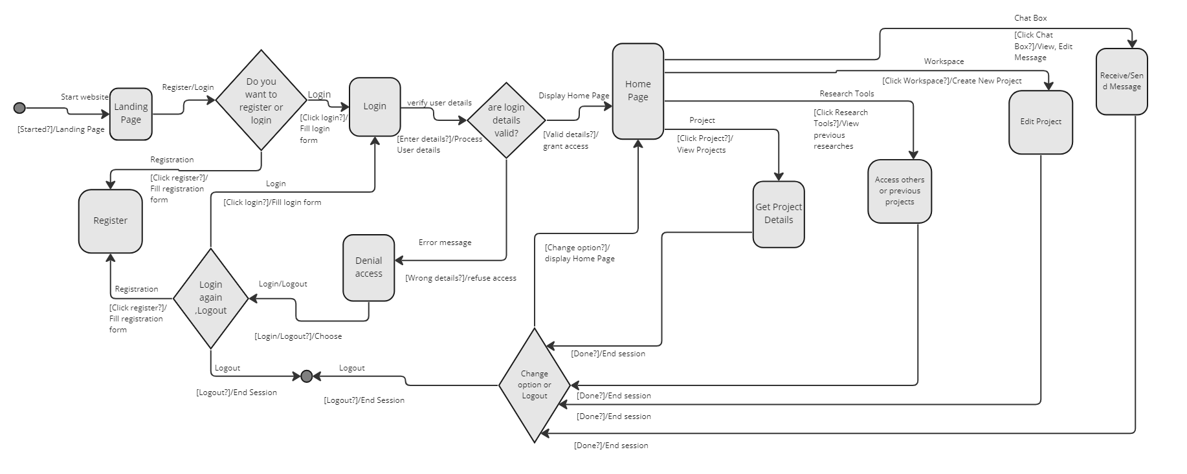

1. For Supervisor

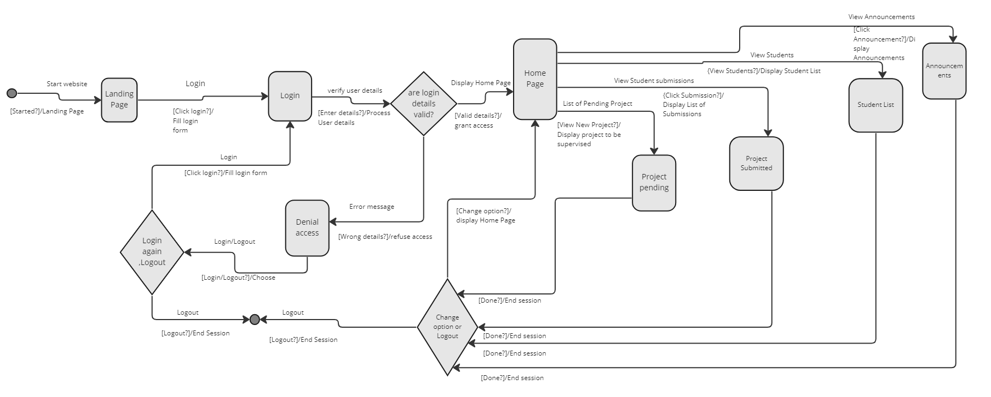

1. For Admin

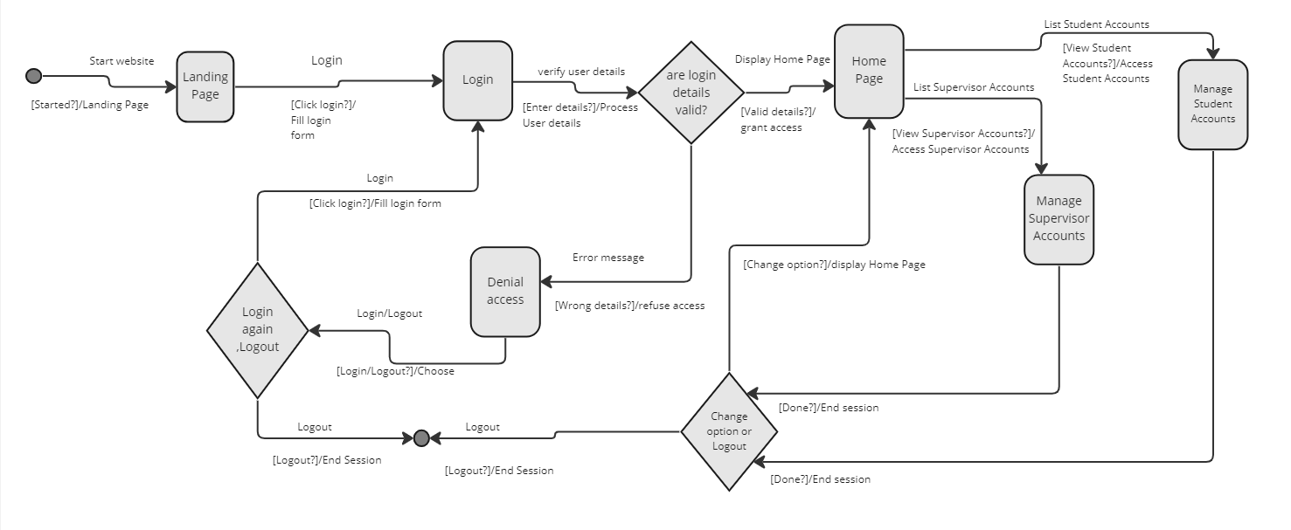

# Recommendations

Based on the Feasibility study, Research DNA will be one the safest system for students who are doing researches in TUT. Affordable, and very easy to manage /maintain.

We are recommending Research DNA System to all Postgraduate Students and their supervisors because the system will help both parties to easily interact about the ongoing and upcoming projects.

* With the system, the Supervisor will be able to send guidance, Feedbacks to his Students.
* The Supervisor could track project’s progress and will be able to view and access submissions.
* Students could conduct their researches or projects in order to submit them to a supervisor

Research DNA will help Student and Supervisor to save time and will simplify or facilitate academic researches.

By using that System, TUT may attract many research Student (Postgraduate Students).

The system will be accessible everywhere and anytime.

# Conclusion

In Summary, Research DNA is an umbrella term for the development of research knowledge, skills, aptitude and abilities that equip a researcher to plan, develop and reproduce scientific output and to act as a supervisor for postgraduate students. Researcher DNA is passed down from established and experienced researchers to novice researchers and postgraduate students.

Research DNA System has two (2) Users, Student/Researcher and Lecturer/Supervisor. The system is managed by an Admin who is responsible to validate Supervisor Accounts and manage both Supervisor and Student Accounts.

The Lecturer will use the system to receive and view submissions, track his Students, view notifications and send Feed-back.

The Student will use the system to conduct and submit research, get Feed-back from his Supervisor and view notifications.